**TechConnect Pro Network Architecture Design**

**Name: Gopikrishna Mogilicharla**

**Github URL: https://github.com/gmogilicharla/Project**

**SQL environment (Windows)**

**Part 1**

**Business Description:**

The firm under consideration is "TechConnect Pro," a vibrant enterprise that specializes in the retail of electronics, laptop accessories, and various gadgets. TechConnect Pro is renowned for its provision of superior, cutting-edge items catering to the needs of computer enthusiasts and professionals.

**Company Size:**

TechConnect Pro has a workforce of over 80 individuals, comprising various roles such as product engineers, sales and marketing specialists, customer support personnel, and logistics professionals. The company's headquarters are located in the vibrant metropolis of San Francisco, California.

**Supply Chain:**

1. **Raw Materials:** a. **Electronic Components**: We source essential electronic components from two key suppliers: CircuitTech Global and ElectroniParts Inc. CircuitTech Global is based in the United States and provides a wide range of integrated circuits and microcontrollers. ElectroniParts Inc. is an international supplier with production facilities in Taiwan, specializing in connectors and electronic accessories.

b. **Plastic Casings**: The plastic casings for our products are primarily supplied by PlastiMold Corp and EcoPlastics International. US-based PlastiMold Corp makes strong plastic shells. With factories in Canada, EcoPlastics International makes eco-friendly and recyclable casings.

c. **Batteries**: PowerCell Enterprises, a leading US battery manufacturer, supplies our batteries. We receive high-capacity lithium-polymer batteries for our electronics.

1. **Primary Office:** TechConnect Pro's headquarters are in bustling San Francisco, California. Placement is based on accessibility to technological centers, skill diversity, and tech-savvy customers.

**Operating Locations:**

TechConnect Pro has offices in New York City, Los Angeles, and Seattle in addition to San Francisco. These cities are distribution centers that distribute merchandise countrywide quickly. The company's internet retail network serves clients nationwide, making its items more accessible.

**Part 2**

**Network Architecture for TechConnect Pro:**

**Tier 1: External Network Layer**

* **Web Server:** This is the starting point for customers. It hosts your website where customers can select various designs and place orders. This front-end device is at the network's edge.
* **External Firewall:** The external firewall protects your internal network from the internet. Filters incoming and outgoing traffic to safeguard your network from threats and illegal access.

**Tier 2: Application and Internal Network Layer**

* **Application Server:** Placed within the internal network, it hosts your website, the sales tool, and other applications, including the APIs used by the website. The firewall is configured to allow these APIs to go through, ensuring secure access.
* **Email Server:** This server manages all email communications for the company. It's situated within the internal network, allowing employees to send and receive emails securely.
* **Employee Server:** This server hosts various internal applications used by employees. It's also within the internal network and serves as the central hub for employee tools.
* **Internal LAN:** The employee server connects to a Local Area Network (LAN), where internal clients (represented by "Client 1" and "Client 2") connect to access company resources and tools.

**Tier 3: Security Layer**

* **IDS/IPS Server:** Positioned in the third tier, the IDS/IPS server functions as an Intrusion Detection System and Intrusion Protection System. It monitors network traffic, detects potential threats, and can take action to block or mitigate them. It connects and protects all tiers, enhancing overall network security.

**Tier 4: Data and Database Layer**

* **DBMS Server:** This server is responsible for managing the Database Management System (DBMS). It's within the internal network, serving as a secure layer for managing the database.
* **Database:** The database itself is hosted within the DBMS server, ensuring that critical data is well-protected within the network architecture. The DBMS server and database form the core of your data management.

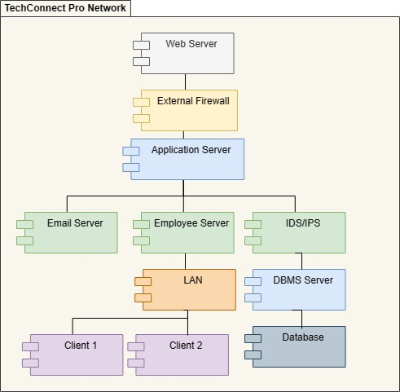

This network architecture is designed to provide strong security and efficient operation. It ensures that external traffic is thoroughly examined and filtered by the external firewall before it reaches the internal network. Internal resources, including the website, email services, and internal applications, are protected behind layers of security.